SOLVE PROBLEMS

KS1 – 2001 Paper

1.

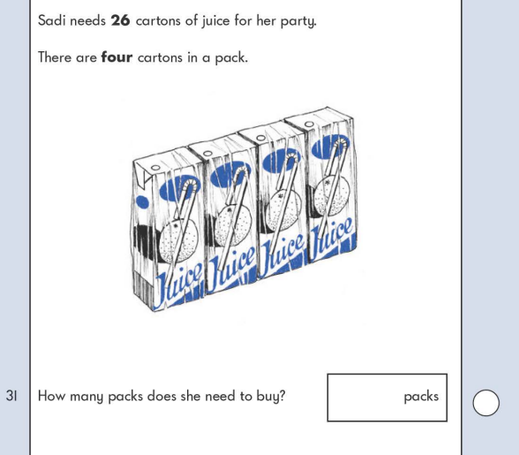

KS1 – 2003 Paper 1

2.

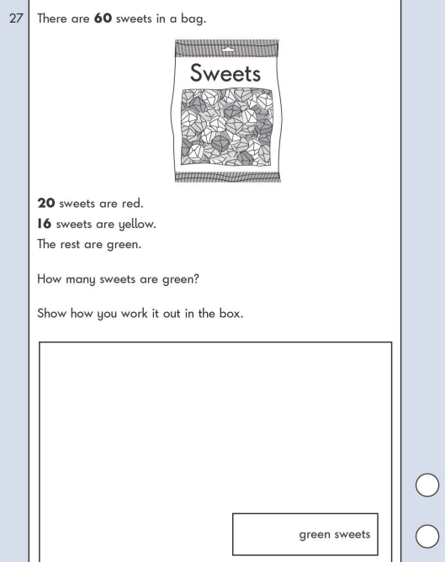

KS1 – 2004 Paper 1

3.

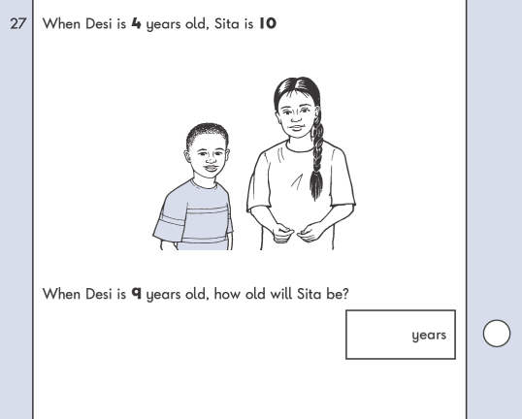

KS1 – 2007 Paper 2

4.

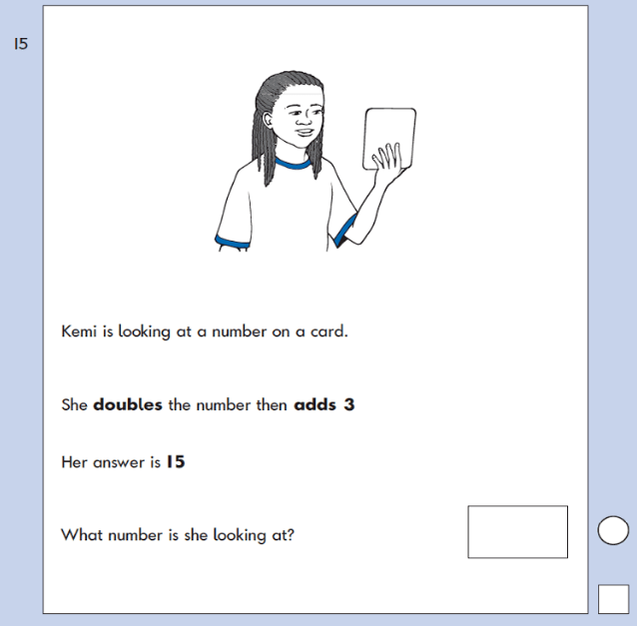

KS1 – 2005 Paper 1

5.

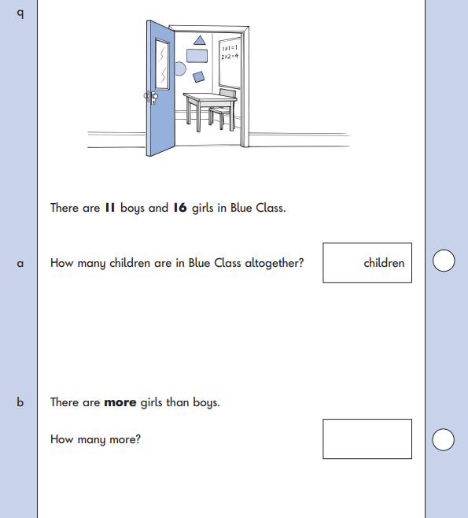

KS1 – 2005 Paper 2

6.

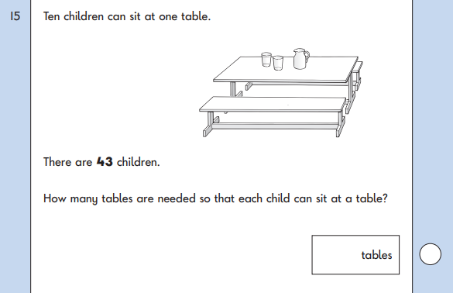

7.

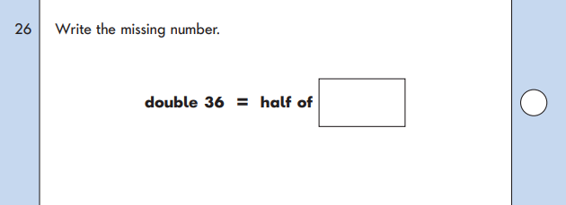

KS1 – 2007 Paper 2

8.

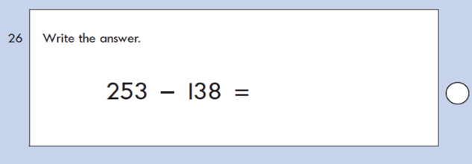

KS1 – 2009 Paper 1

9.

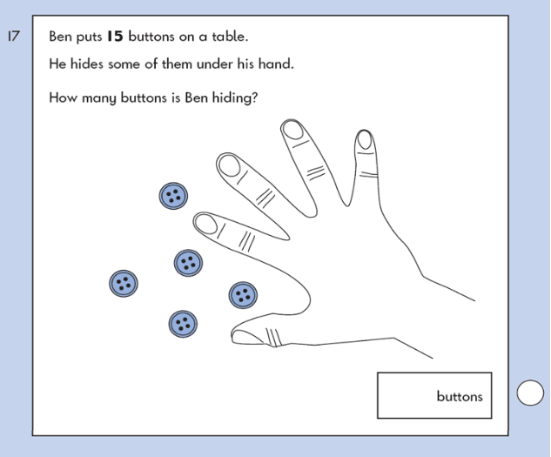

KS1 – 2009 Paper 2

10.

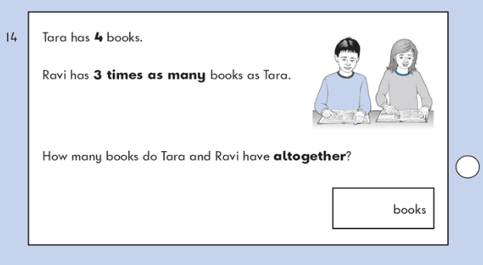

11.

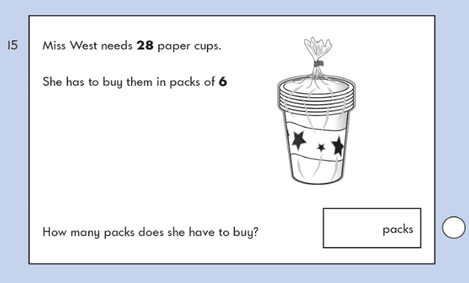

12.

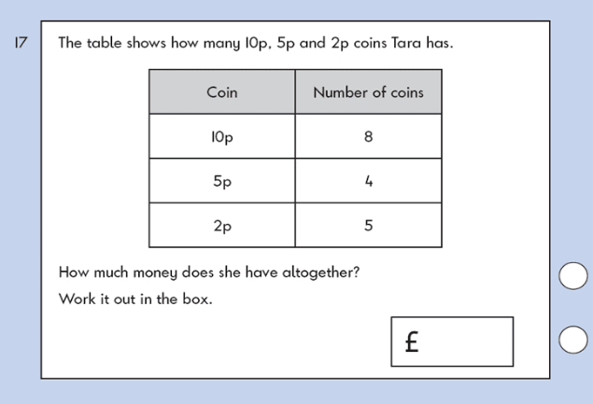

KS1 – 2016 Paper - Reasoning

13.

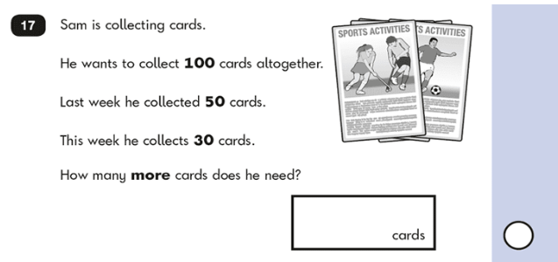

14.

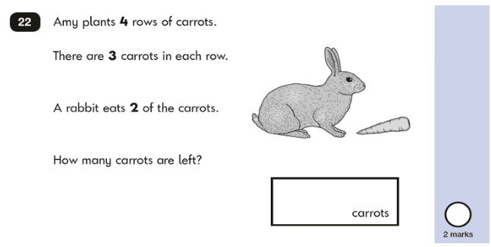

KS1 – 2016 Paper – Reasoning (Second)

15.

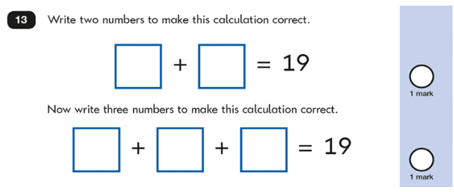

KS1 – 2017 Paper – Reasoning

16.

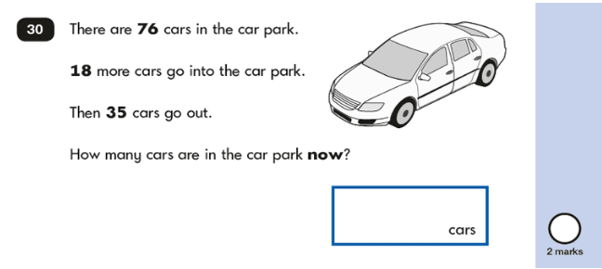

KS1 – 2018 Paper – Reasoning

17.

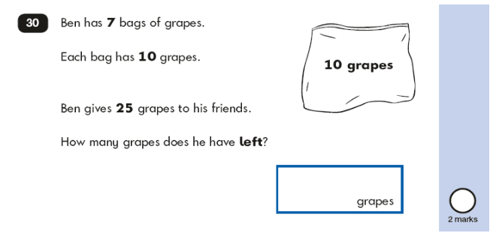KS1 – 2022 Paper – Reasoning

18.

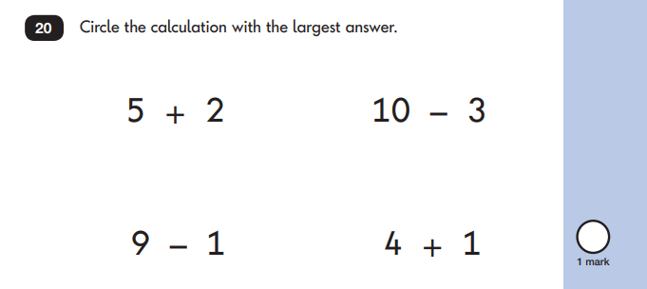

19.

